[
REPORT ON DAY–1 ACTIVITIES UNDER SWACHHTA HI SEVA (SHS) 2026

Theme: “Swachhta Mein Sahbhag – Swachh Bharat, Viksit Bharat”

Date: 17 September 2026

Venue: ICAR–National Research Centre on Yak, Dirang, Arunachal Pradesh

The Swachhta Hi Sewa (SHS) 2026 campaign commenced on 17 September 2026 across ICAR Institutes, KVKs and other establishments as part of the nationwide campaign on cleanliness and sanitation. The campaign is being organised under the theme “Swachhta Mein Sahbhag – Swachh Bharat, Viksit Bharat”, with emphasis on collective participation, cleanliness, hygiene, sanitation and responsible waste management.
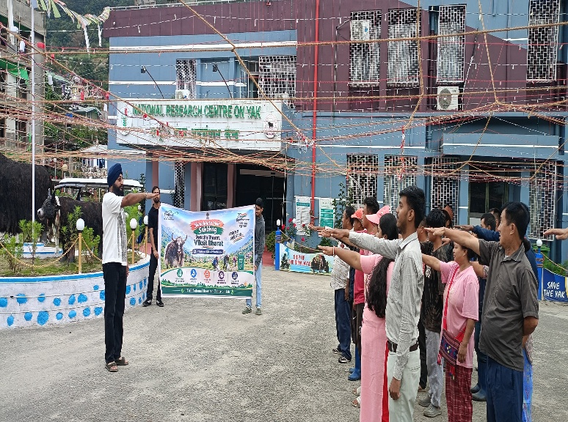
In accordance with the Date-wise Action Plan for Swachhta Hi Seva 2026, the Day–1 activities at ICAR–National Research Centre on Yak, Dirang were undertaken with the objective of creating awareness about cleanliness and encouraging active participation of employees and the community in maintaining a clean, hygienic and sustainable environment.
1. Display of Swachhta Awareness Banners
As part of the launch-day activities, Swachhta-related banners and awareness messages were displayed at prominent locations within the Institute premises. The display was aimed at highlighting the importance of cleanliness and sanitation and creating greater visibility for the Swachhta Hi Seva campaign.
The campaign messages also encouraged individuals to adopt cleanliness as a regular practice and to contribute towards maintaining clean surroundings at their workplaces, homes and public spaces.
2. Swachhta Pledge
A Swachhta pledge was undertaken by the staff and participants of the Institute as part of the Day–1 programme. Through the pledge, the participants reaffirmed their commitment towards maintaining cleanliness and hygiene and promoting responsible behaviour concerning sanitation and waste disposal.
The activity also emphasized that achieving the objectives of Swachh Bharat requires continuous participation and cooperation from every individual rather than cleanliness being viewed only as an occasional activity.
3. Cleanliness and Hygiene Awareness
During the programme, emphasis was laid on the importance of maintaining clean and hygienic surroundings within the Institute premises. Employees were encouraged to maintain cleanliness in their respective work areas and to ensure proper disposal of waste.
The participants were also sensitized to the importance of avoiding littering, maintaining cleanliness in common areas and adopting responsible waste-management practices in their day-to-day activities.
4. Promotion of Collective Participation
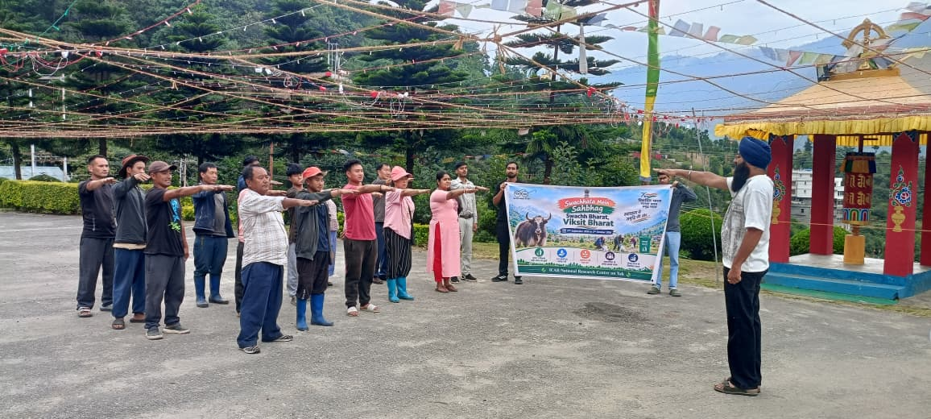
The Day–1 programme highlighted the central message of the SHS campaign, i.e. “Swachhta Mein Sahbhag”, which focuses on active participation and collective responsibility.
The programme encouraged employees and other stakeholders to contribute towards cleanliness activities and to motivate people in their respective communities to adopt a clean and healthy way of life. The importance of individual responsibility, community participation and sustained efforts towards cleanliness was also emphasized.
5. Awareness Regarding Swachh Way of Life
The launch-day activities further focused on encouraging participants to incorporate cleanliness and hygiene into their daily routine. The campaign message of adopting a “Swachh Way of Life” was disseminated among the participants, with emphasis on maintaining clean surroundings, proper sanitation practices and responsible management of waste.
The activities were undertaken with the broader objective of creating behavioural awareness and encouraging sustained participation beyond the campaign period.
6. Outcome of the Programme
The Day–1 activities provided an appropriate commencement to the Swachhta Hi Sewa 2026 campaign at the Institute. The programme helped in creating awareness among employees regarding the importance of cleanliness, hygiene and sanitation and reinforced the concept of collective responsibility towards maintaining a clean environment.
The activities also served to sensitise the participants about the objectives of the SHS campaign and encouraged them to actively participate in the forthcoming Swachhta-related activities to be organized during the campaign period.

Conclusion
The Day–1 programme of Swachhta Hi Sewa 2026 was successfully undertaken at ICAR–National Research Centre on Yak, Dirang on 17 September 2026 in accordance with the prescribed action plan. The programme focused on awareness generation, cleanliness, sanitation and collective participation under the theme “Swachhta Mein Sahbhag – Swachh Bharat, Viksit Bharat.”
The Institute remains committed to promoting cleanliness, hygiene and responsible waste-management practices and to actively participating in the various activities planned under Swachhta Hi Sewa 2026 from 17 September to 2 October 2026.

